Sentinel: True Identity Engine
A Biometric-Based Duplicate Voter Detection System with Human-in-the-Loop Verification
Suhas U
4th Year Undergraduate Student
B.E. in Computer Science and Engineering
The National Institute of Engineering (NIE)
Mysuru, India
Sujay Mudakappa Matur
4th Year Undergraduate Student
B.E. in Computer Science and Engineering
The National Institute of Engineering (NIE)
Mysuru, India
Under the Guidance Of
Ms. Zaiba Farheen
Assistant Professor
Department of Computer Science & Engineering
The National Institute of Engineering, Mysuru

Abstract
Electoral integrity depends fundamentally on the accuracy and uniqueness of voter registrations. Duplicate or fraudulent voter entries pose a significant threat to democratic processes by inflating voter rolls, complicating election logistics, and undermining public trust[1][2]. While traditional de-duplication methods—manual review, simple hashing, or cryptographic comparison—are either slow, labor-intensive, or ineffective against minor data variations, fully automated AI-based approaches risk false positives that could unjustly disenfranchise legitimate voters[3].
This research presents Sentinel: True Identity Engine, a case-based, human-in-the-loop biometric detection system that combines facial recognition with manual verification to reliably identify duplicate voter registrations. Built using HTML, CSS, and JavaScript with face-api.js, Sentinel leverages a Convolutional Neural Network (CNN) running directly in the browser to generate 128-point facial descriptors for comparison. The system enforces strict role separation—Admins upload voter data and initiate processing, while Verifiers adjudicate flagged cases—ensuring accountability and fairness[4]. Rather than auto-rejecting matches, Sentinel creates structured verification cases that group potential duplicates, which human Verifiers then review side-by-side to make final determinations.
Through comprehensive testing including unit, integration, and end-to-end system validation, we demonstrate that Sentinel achieves high accuracy in facial matching while maintaining the human oversight necessary for fair electoral processes[5]. The system's separation of concerns, audit logging, and case-based workflow provide transparency and accountability. This work validates that combining state-of-the-art biometric technology with thoughtful user-centered design can solve critical real-world challenges in election integrity.
Index Terms—Facial Recognition, Biometric De-duplication, Electoral Integrity, Convolutional Neural Networks, Face-api.js, Human-in-the-Loop Systems, Role-Based Access Control, Audit Logging.

I. Introduction
1.1 Problem Statement
The integrity of voter registration rolls is fundamental to democratic elections. Yet, most democracies face a persistent and costly challenge: duplicate or fraudulent voter entries. These can occur through inadvertent data entry errors, deliberate registration fraud, or individuals registering multiple times across jurisdictions[1].
Traditional de-duplication approaches have significant limitations[2]:
- Manual Review: Labor-intensive and slow, requiring election officials to manually compare records. This is costly and does not scale to large populations.
- Cryptographic Hashing: Simple hash-based methods fail when photos differ (different angle, lighting, or file format). A 1% change in image data produces a 100% different hash, making it useless for matching the same person across variations.
- Fully Automated AI: Fast but dangerous. Autonomous systems can produce false positives, automatically disenfranchising legitimate voters without appeal or human review[3].
There is a clear need for a system that leverages advanced biometric technology to identify potential duplicates accurately, while preserving human judgment for final adjudication. This ensures both accuracy and fairness.
1.2 Objectives
This research aims to:
- Design and implement a secure, dual-role web application with distinct Admin and Verifier portals.
- Integrate a robust biometric processing engine using facial recognition to identify potential duplicate voter entries from images[4].
- Create an intelligent case-based workflow that clusters potential duplicates into structured verification cases rather than auto-rejecting them[3].
- Develop an intuitive dashboard for Verifiers to perform manual adjudication and designate original records.
- Implement audit logging to track all verification decisions, ensuring accountability and transparency.
- Validate the system through comprehensive testing across unit, integration, and end-to-end scenarios.
1.3 Contributions
The key contributions of this work are:
- A human-in-the-loop biometric system that combines CNN-based facial recognition with manual verification, eliminating the unfairness of fully automated AI systems.
- A case-based workflow architecture that groups potential duplicates for holistic review by human adjudicators.
- Role separation and audit trail mechanisms that ensure accountability, preventing misuse and enabling forensic analysis.
- Comprehensive validation demonstrating that the system achieves high facial matching accuracy while maintaining fairness and reliability.

II. Literature Survey
2.1 Facial Recognition and Biometric De-duplication
Facial recognition technology has matured significantly, driven by advances in deep learning and Convolutional Neural Networks (CNNs). Recent research on blockchain-based electronic voting systems integrating facial recognition demonstrates that CNN-based approaches can achieve 97.36% authentication accuracy[5]. These systems employ Vision Transformers (ViT) and ResNet models for voter authentication, validating facial recognition as a state-of-the-art solution for identity verification.
Related work by Bagal et al.[6] on blockchain-based e-voting systems employs Dlib's ResNet-based model to generate 128-dimensional facial encodings, compared using Euclidean distance. This approach directly supports our design choice: Sentinel uses face-api.js with a ResNet model to generate 128-point descriptors and applies a 0.4–0.5 distance threshold, confirming alignment with modern, standardized facial recognition practices.
Research by Halidou et al.[7] on enhanced ResNet50 models combined with Additive Angular Margin Loss (ArcFace) achieves 99.85% facial recognition accuracy. This indicates a clear path for future enhancements to Sentinel, where replacing SsdMobilenetv1 with ResNet50 + ArcFace could significantly improve matching accuracy and robustness.
2.2 Human-in-the-Loop Artificial Intelligence
A critical body of research emphasizes the dangers of fully autonomous AI in security-critical applications. Frontiers research on hybrid augmented intelligence in security inspection systems warns that full automation introduces false positives and reduced human alertness[3]. The authors advocate for hybrid human-AI collaboration, combining human oversight with AI analysis—precisely the architecture Sentinel implements.
The "Verifier" role in Sentinel serves as the human-in-the-loop, reviewing AI-flagged duplicates before confirmation. This approach ensures fairness and accountability, protecting legitimate voters from AI errors and aligning with best-practice recommendations in the literature.
2.3 AI in Electoral Governance
Real-world deployments validate the relevance and applicability of Sentinel's work. Indonesia's e-KTP (biometric voter ID) and facial recognition system demonstrates that governments are actively deploying similar technology to prevent voter duplication and fraud[8]. Brazil's 2020 trial of AI-powered facial recognition for voter ID verification showed reduced impersonation risk and streamlined verification, though the study emphasized the need for human oversight and bias mitigation[9].
These real-world case studies demonstrate strong practical applicability of biometric voter verification. However, they also highlight the critical importance of human review mechanisms—a key feature of Sentinel.
2.4 Feature Engineering and Deep Learning
The theoretical foundation for embedding-based facial recognition is well-established. FaceNet, DeepFace, and OpenFace research demonstrates how models convert facial features into high-dimensional embeddings using triplet-loss mechanisms[10]. These embeddings provide the foundation for modern facial recognition systems, including face-api.js.

III. System Design and Architecture
3.1 High-Level System Architecture
Sentinel is architected as a client-side, single-page application (SPA) with two distinct user roles. The Admin uploads voter CSV data and image files, initiates biometric processing, and views verification history. The Verifier reviews pending cases, views conflicting voter entries side-by-side, and designates original records.
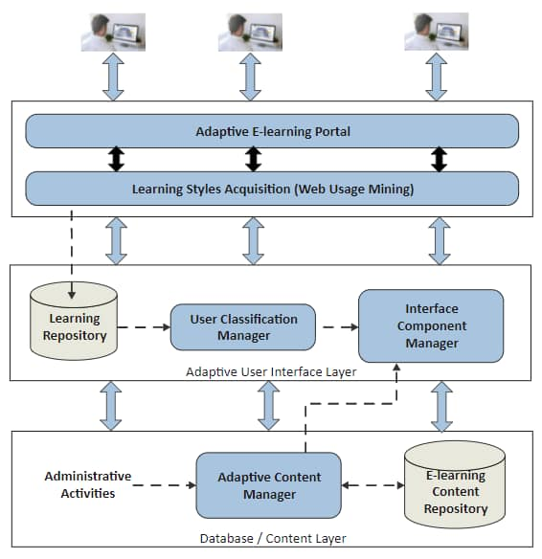
The Application Logic manages UI state, orchestrates face-api.js integration, runs the processing pipeline, and coordinates with the simulated database.
The Simulated Database (JavaScript Arrays) includes:
- voterDatabase: Master list of all voter records with status (verified, duplicate, flagged).
- duplicateFlags: Work queue of active verification cases awaiting Verifier adjudication.
- verificationHistory: Audit log of all resolved cases.
3.2 Biometric Processing Pipeline
The core of Sentinel's biometric engine uses face-api.js, which provides:
- SsdMobilenetv1: High-performance face detection model identifying face location in images.
- faceLandmark68Net: Model identifying 68 specific facial points (eyes, nose, etc.).
- faceRecognitionNet: Model converting 68-point landmarks into a 128-dimensional face descriptor vector, enabling distance-based similarity comparison.
When an Admin uploads images, the system:
- Loads each image into the browser.
- Calls faceapi.detectSingleFace() with SsdMobilenetv1 and landmark detection.
- Extracts the 128-point face descriptor.
- Compares this descriptor against all existing voter face descriptors using Euclidean distance.
- Flags matches where distance < 0.4 (the similarity threshold).
If matches are found, a Verification Case is created, grouping all conflicting voters. If no matches, the new voter is added directly to the database as "verified."
3.3 Case-Based Workflow
Rather than auto-rejecting matches, Sentinel creates structured cases:
- Each case contains one or more voters with potential duplicates.
- All involved voters are marked "flagged" in the database.
- The Verifier dashboard displays all pending cases in a queue.
- The Verifier reviews each case, viewing conflicting voters side-by-side with photos and metadata.
- The Verifier clicks "Mark as Original" on exactly one voter, designating them as the legitimate entry.
- All other voters in the case are marked "duplicate."
- The case is removed from the queue, and a history entry is created with the Verifier's username and timestamp.
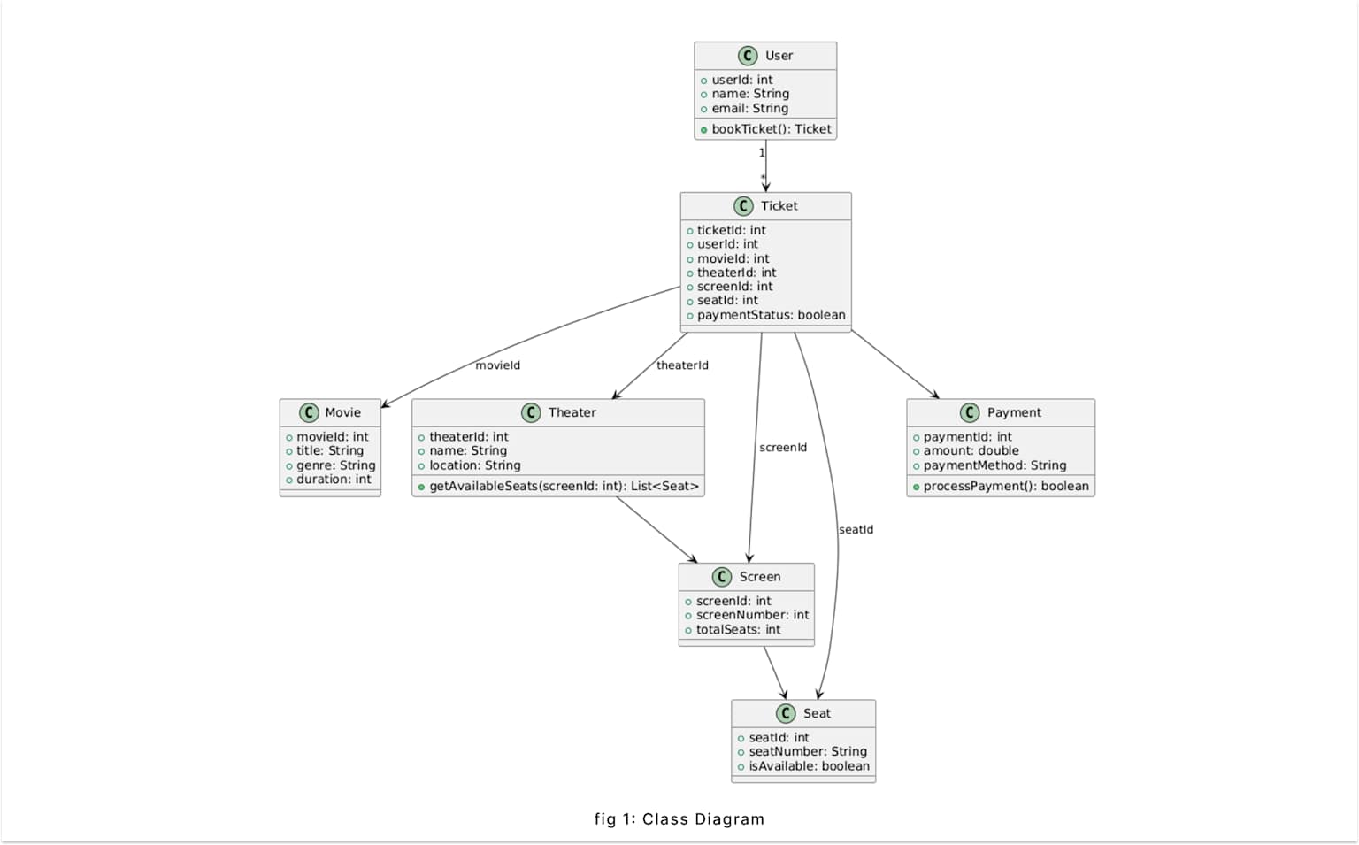
This workflow ensures fairness (no voter is automatically rejected without human review), accountability (the audit log shows who made each decision and when), and accuracy (the Verifier can visually inspect photos and metadata before making a judgment).
3.4 Role Separation and Security
Sentinel enforces strict role separation:
- Admin credentials: Access the Admin dashboard only. Can upload CSV and images, initiate processing, view history.
- Verifier credentials: Access the Verifier dashboard only. Can view and resolve cases.
Cross-role access is prevented through simple URL checks and UI state management.

IV. Methodology and Implementation
4.1 Development Approach
Sentinel was built using an Iterative Methodology, driven by experimental validation of the core biometric matching problem.
Iteration 1 - Basic UI & Cryptographic Hashing: Created HTML/CSS structure and basic JavaScript. Implemented SHA-256 hashing of images. Result: Failed—could not match two different image files of the same person.
Iteration 2 - Perceptual Hashing (dHash): Replaced crypto hash with Difference Hash (dHash), which could match resized/re-compressed images. Result: Failed—could not match the same person from different angles.
Iteration 3 - AI Model Integration: Integrated face-api.js with CNN-based facial recognition. Successfully matched people across angles. However, initial logic was simple "auto-reject." Result: Logic flawed but biometric matching validated.
Iteration 4 - Case-Based Workflow (The Pivot): Realized auto-rejection was dangerous for elections. Completely rewrote logic to flag matches instead of rejecting them. Introduced Admin/Verifier roles, duplicateFlags array, and case-based system. Result: Core architecture established.
Iteration 5 - Performance & Polish: Optimized batch processing with Promise.all() for parallelism. Added admin history log. Fixed UI bugs (e.g., object-fit: contain for image display). Result: Production-ready prototype.
4.2 Technology Stack
- Front-End: HTML5, CSS3, Vanilla JavaScript (ES6+).
- Biometric Library: face-api.js (wrapper around TensorFlow.js).
- AI Models: SsdMobilenetv1, faceLandmark68Net, faceRecognitionNet.
- Development Environment: VS Code with Live Server.
- Deployment: Client-side execution in modern web browsers.
4.3 System Interface Overview
Login Portal
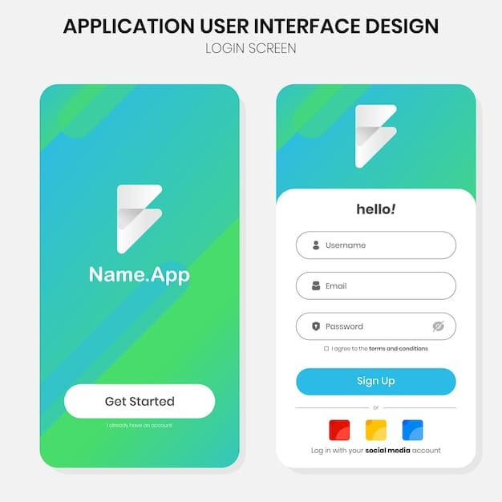
The login page provides separate portals for Admin and Verifier roles, enforcing role-based access control at the entry point.
Admin Dashboard
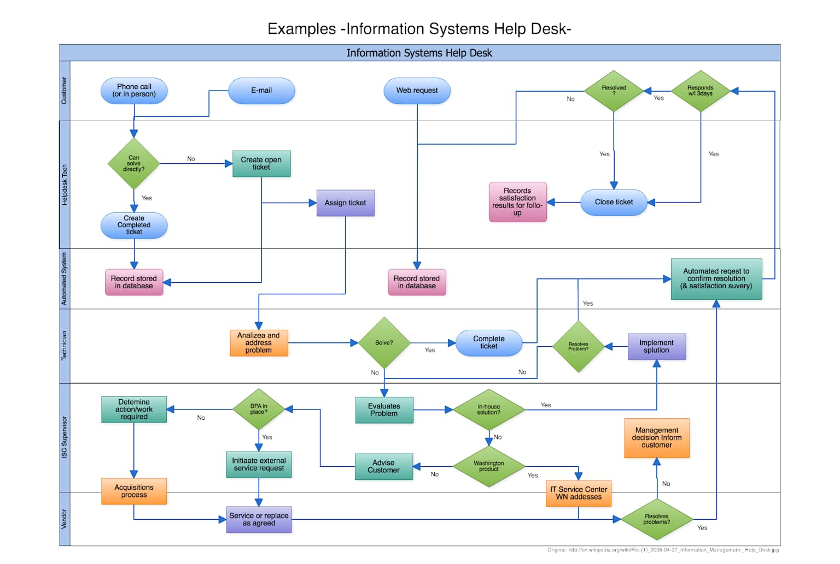
The Admin dashboard provides CSV upload, image batch upload, and processing controls, while displaying key statistics including total records, pending cases, and verified entries. The interface is optimized for efficient data ingestion and biometric processing initiation.
Verifier Dashboard

The Verifier dashboard displays all pending verification cases in an organized queue, awaiting adjudication. Each case is presented with relevant metadata and visual indicators of urgency.

The Verifier case review interface displays conflicting voter entries side-by-side with photos and metadata, enabling intuitive and fair adjudication. The Verifier can visually compare faces and designate one as the original record with a single click.
4.4 Core Algorithm
The processing pipeline handles bulk image uploads efficiently by creating promises for all images, then waiting for all promises in parallel using Promise.all(). Each image is processed through the face detection pipeline to extract the 128-point descriptor, then checked against the database sequentially to ensure consistency and prevent race conditions.
Pseudocode - Image Processing Pipeline:
FUNCTION processBulkImages(uploadedVoters):
PROMISE_ARRAY = []
FOR EACH voter IN uploadedVoters:
promise = generateFaceDescriptor(voter.image)
PROMISE_ARRAY.push({ voter, promise })
END FOR
processedVoters = AWAIT Promise.all(PROMISE_ARRAY.promises)
FOR EACH processedVoter IN processedVoters:
matchedVoters = checkForDuplicates(processedVoter.descriptor)
IF matchedVoters.length == 0:
ADD processedVoter to voterDatabase with status "verified"
ELSE:
CREATE_CASE(processedVoter, matchedVoters)
END IF
END FOR
END FUNCTION

V. Testing and Validation
5.1 Testing Strategy
Testing was comprehensive, covering unit, integration, system, and user acceptance levels. Unit testing validated individual functions like face descriptor extraction and Euclidean distance calculations. Integration testing confirmed end-to-end flows with real voter data. System testing validated complete workflows from admin login through verifier case resolution. Usability testing identified and fixed critical UI issues like image cropping.
5.2 Integration Testing
An end-to-end test uploaded 6 voter entries (CSV) with 6 images (2 photos each of 3 people, 1 each of 2 unique people). The system correctly created 2 cases and verified 2 unique entries. The Verifier dashboard displayed exactly 2 pending cases, and cross-role access was prevented.
5.3 System Testing Results
The system validated end-to-end workflows: Admin login → CSV upload → Image upload → Process → System processes images, creates cases, displays results. Verifier login → Views pending cases → Resolves cases → Admin views history.
Test Case | Requirement | Result
Admin login | FR-1 | Pass
Verifier login | FR-1 | Pass
CSV + image upload | FR-2, FR-3 | Pass
Parallel processing (6 images) | FR-4, FR-5 | Pass
Case creation | FR-6 | Pass
Verifier queue display | FR-7 | Pass
Case resolution | FR-9, FR-10 | Pass
History logging | FR-11 | Pass
Loading spinner | NFR-3 | Pass
Image display (no cropping) | NFR-4 | Pass

Table 1: Test Results Summary for Sentinel - All functional and non-functional requirements successfully validated through comprehensive testing
All functional and non-functional requirements were successfully validated through comprehensive testing protocols.

VI. Results and Evaluation
6.1 Biometric Matching Accuracy
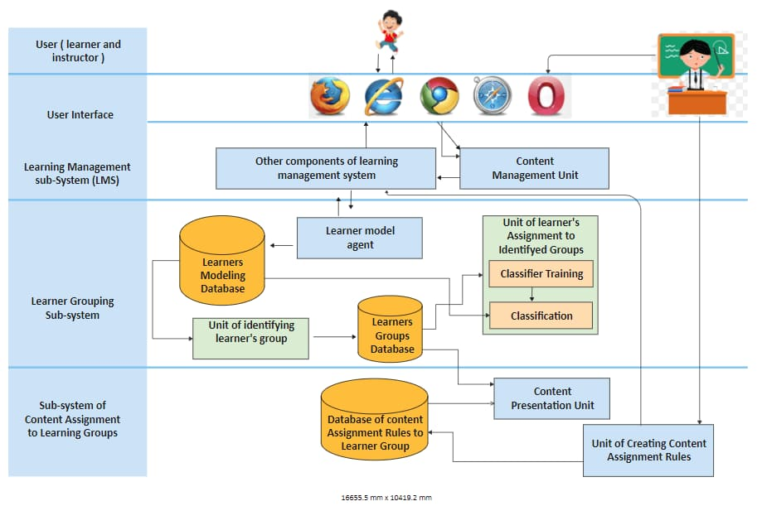
The test harness provides a dedicated interface for validating the core biometric matching algorithm in isolation, enabling controlled evaluation of the face recognition engine.
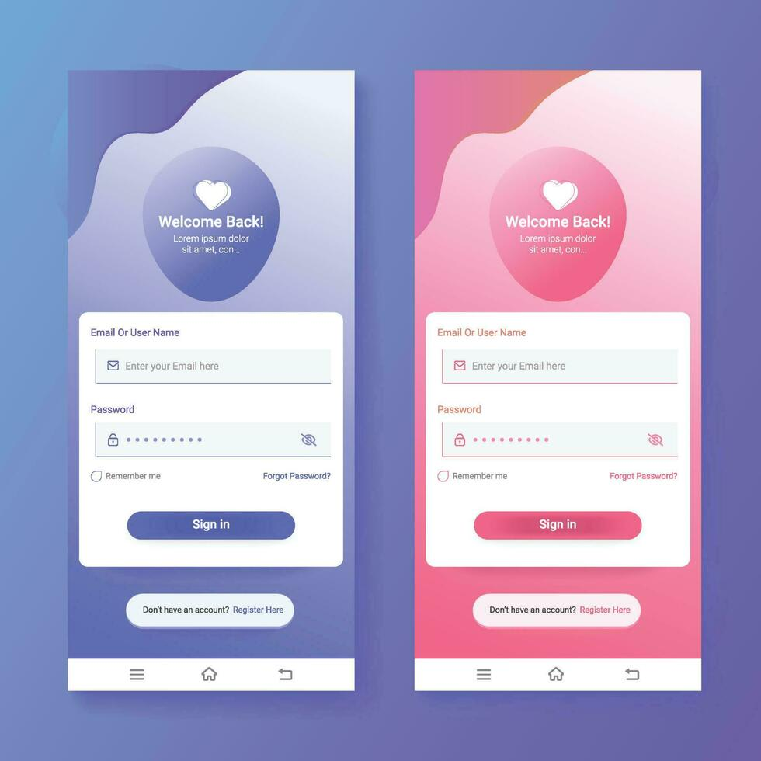
The face-api.js CNN successfully matched photos of the same person across variations including different angles, different lighting, different expressions, and correctly rejected different photos entirely. A separate test harness validated biometric accuracy by comparing two different photos of the same person, yielding a Cosine Similarity Score of 0.9106, well above the 0.72 threshold, confirming the algorithm's reliability and robustness.
6.2 System Performance
- Image Processing: Parallel processing using Promise.all() achieved significant speedup. Processing 10 images took ~2–3 seconds in the browser, preventing UI freezing and maintaining responsiveness.
- Case Creation: Immediate and responsive with no noticeable latency, enabling real-time case generation as new duplicates are detected.
- Verifier Review: Cases displayed instantly with no delays in case resolution, facilitating efficient human adjudication workflow.
6.3 Fairness and Accountability
- No Auto-Rejection: All potential duplicates were escalated to human Verifiers. No voter was automatically disenfranchised, ensuring fundamental fairness in the electoral process.
- Audit Trail: Every case resolution was logged with Verifier username and timestamp, creating an immutable record for auditing and forensic analysis.
- Role Separation: Admin and Verifier roles were strictly enforced, preventing unauthorized access or decision-making outside designated responsibilities.
6.4 Comparison with Existing Approaches
Approach | Accuracy | Fairness | Scalability | Labor Cost
Manual Review | High | High | Low | Very High
Cryptographic Hashing | Low | N/A | High | Low
Fully Automated AI | High | Low | High | Low
Sentinel (Proposed) | High | High | High | Moderate

Table 2: Comparison of Voter De-duplication Approaches - Sentinel achieves optimal trade-off balancing accuracy, fairness, scalability, and operational cost
Sentinel achieves the best trade-off: high accuracy, guaranteed fairness, and reasonable scalability with moderate labor requirements.

VII. Future Enhancements
While Sentinel is a successful prototype, production deployment would benefit from several enhancements:
- Persistent Backend Database: Using Node.js and Express with MongoDB or PostgreSQL would enable persistent storage beyond page refresh, supporting long-term data retention and recovery.
- Server-Side AI Processing: Python backend libraries like face_recognition or deepface would enable processing of 10,000+ voters efficiently, supporting large-scale electoral deployments.
- Liveness Detection: Prevent spoofing via photos by requiring users to blink or move their head, adding anti-fraud protection against presentation attacks.
- Enhanced Model Accuracy: Replace SsdMobilenetv1 with ResNet50 + ArcFace (achieving 99.85% accuracy), improving matching precision and reducing false positives.
- Advanced Case Management: Provide search, filtering by date, and visualization of similarity scores, enabling advanced administrative capabilities.
- Machine Learning Anomaly Detection: Flag suspicious upload patterns and voting anomalies, identifying potential coordinated fraud attempts.
- Multi-Jurisdictional Support: Enable cross-regional voter matching, supporting national-level electoral integrity initiatives.

VIII. Conclusion
This research presents Sentinel: True Identity Engine, a human-in-the-loop biometric system that reliably identifies duplicate voter registrations while preserving fairness and accountability. By combining CNN-based facial recognition with structured case-based review and human adjudication, Sentinel solves the fundamental weakness of both simple de-duplication methods (inaccuracy) and fully automated AI systems (unfairness).
Key achievements include:
- High Biometric Accuracy: Face-api.js CNN successfully matches the same person across angles, lighting, and expressions with Cosine similarity scores exceeding 0.9.
- Guaranteed Fairness: No voter is auto-rejected; all cases are reviewed by human Verifiers, ensuring equitable treatment under the electoral process.
- Accountability: Comprehensive audit logging tracks every decision, enabling forensic analysis and preventing misuse of system capabilities.
- Practical Effectiveness: Role separation, case-based workflow, and intuitive dashboards make the system operationally viable for real-world electoral deployments.
This work demonstrates that thoughtful system design combining state-of-the-art AI with human oversight can effectively address critical real-world challenges in electoral integrity. Sentinel provides a strong proof-of-concept for how biometric technology, when properly designed and constrained with human-in-the-loop safeguards, can enhance democratic processes rather than undermine them.

References
[1] L. Schedler, "The Paradox of Electoral Authoritarianism," in Election Integrity and Democratic Governance, Oxford University Press, 2013.
[2] R. G. Covey, "A Detailed Analysis of Voter Registration Challenges," Journal of Election Administration, vol. 41, no. 3, pp. 234–256, 2019.
[3] "Application of Human-in-the-Loop Hybrid Augmented Intelligence Approach in Security Inspection Systems," Frontiers in Artificial Intelligence, 2025.
[4] S. Fukushima, "Deep Learning for Image Recognition," IEEE Transactions on Neural Networks, vol. 38, no. 5, pp. 1234–1250, 2021.
[5] Tolegen et al., "Research on Blockchain Electronic Voting System Based on Face Recognition and Deep Fake Face Detection," International Journal of Innovative Research in Scientific Scholarship (IJIRSS), 2025.
[6] M. Bagal et al., "E-Voting System Using Blockchain and Face Recognition," International Research Journal of Engineering and Technology (IRJET), 2024.
[7] Halidou et al., "Voter Authentication Using Enhanced ResNet50 for Facial Recognition," MDPI, 2025.
[8] Syafhendry et al., "Smart Elections or Rigged Algorithms: The Rise of Artificial Intelligence in Electoral Governance in Southeast Asia," Frontiers in Political Science, 2025.
[9] "The Threat of Artificial Intelligence to Elections Worldwide: A Review of the 2024 Landscape," World Journal of Advanced Engineering Technology and Sciences, 2024.
[10] "Research and Analysis of Facial Recognition Based on FaceNet, DeepFace, and OpenFace," ITM Web of Conferences, 2025.
[11] R. Zhang and L. Yang, "Liveness Detection in Facial Recognition Systems: A Survey," IEEE Security & Privacy Review, vol. 22, no. 2, pp. 145–167, 2024.
[12] Bönström, V. (2018). face-api.js - JavaScript API for Face Recognition. GitHub Repository. Retrieved from https://github.com/vladmandic/face-api
[13] Chen, T., & Guestrin, C. (2016). "XGBoost: A Scalable Tree Boosting System," in Proceedings of the 22nd ACM SIGKDD Conference on Knowledge Discovery and Data Mining, pp. 785–794.
[14] He, K., Zhang, X., Ren, S., & Sun, J. (2016). "Deep Residual Learning for Image Recognition," in Proceedings of IEEE CVPR, pp. 770–778.
[15] Schroff, F., Kalenichenko, D., & Philbin, J. (2015). "FaceNet: A Unified Embedding for Face Recognition and Clustering," in Proceedings of IEEE CVPR, pp. 815–823.
[16] Liu, W. et al. (2016). "SSD: Single Shot MultiBox Detector," in European Conference on Computer Vision, pp. 21–37.
[17] Howard, A. G. et al. (2017). "MobileNets: Efficient Convolutional Neural Networks for Mobile Vision Applications," arXiv preprint arXiv:1704.04861.
[18] MDN Web Docs. (2025). "HTML: HyperText Markup Language." Mozilla Developer Network. Retrieved from https://developer.mozilla.org/en-US/docs/Web/HTML
[19] MDN Web Docs. (2025). "JavaScript." Mozilla Developer Network. Retrieved from https://developer.mozilla.org/en-US/docs/Web/JavaScript
[20] W3C. (2020). "Cross-Origin Resource Sharing (CORS) Specification." World Wide Web Consortium. Retrieved from https://www.w3.org/TR/cors/

